|  |  |
| --- | --- |
| Team ID | PNT2022TMID13904 |
| Project Name | CONTAINMENT ZONE ALERTING |

SETUP MOBILE APPLICATION ENVIRONMENT

INSTALL ANDROID STUDIO

1. Open any web browser and navigate to the Android Studio download page.
2. Click Download Android Studio to start the download.
3. Double-click the downloaded ﬁle.

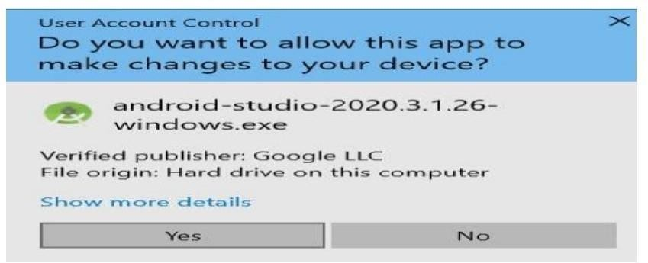

when the installation is done to launch Android Studio.

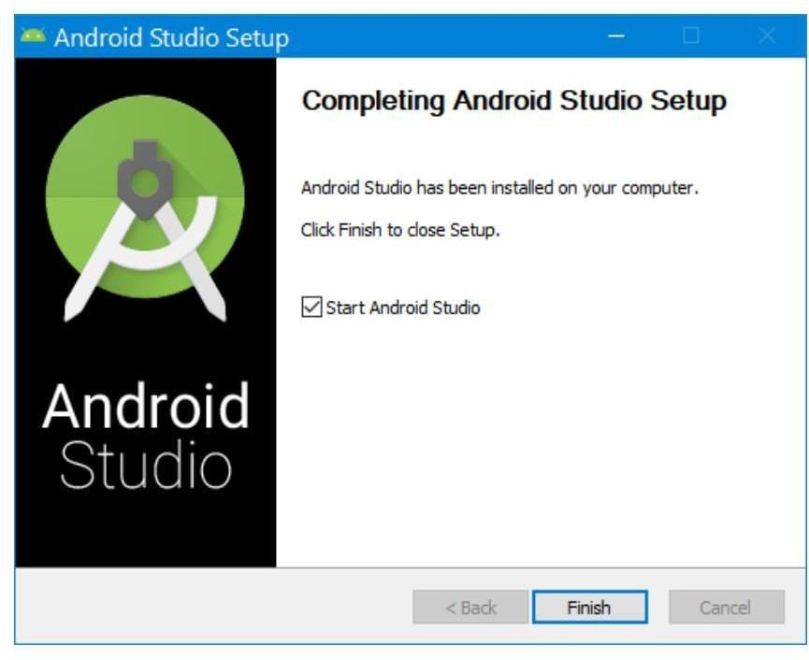

Click Allow Access, if needed, to continue the installation.

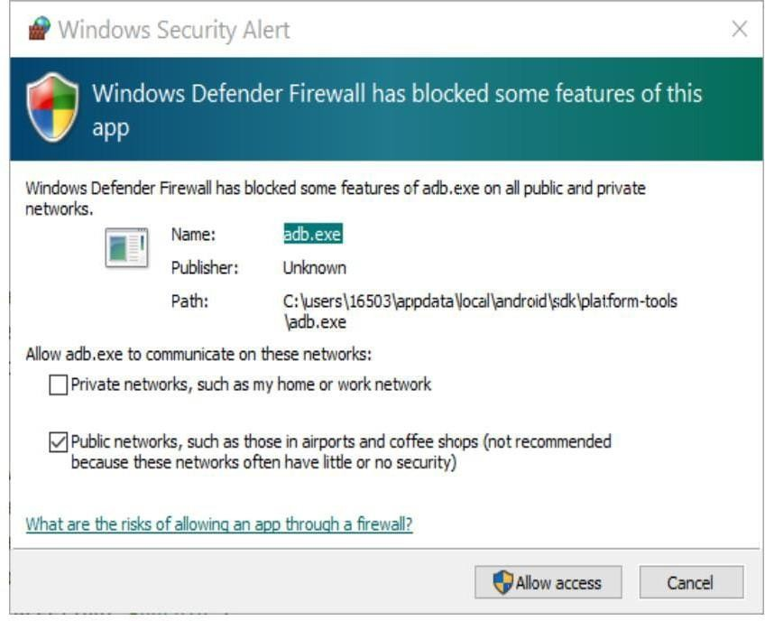

window displays Welcome to Android Studio

